Loyola Maryland Renaissance Faire
Spring 2023

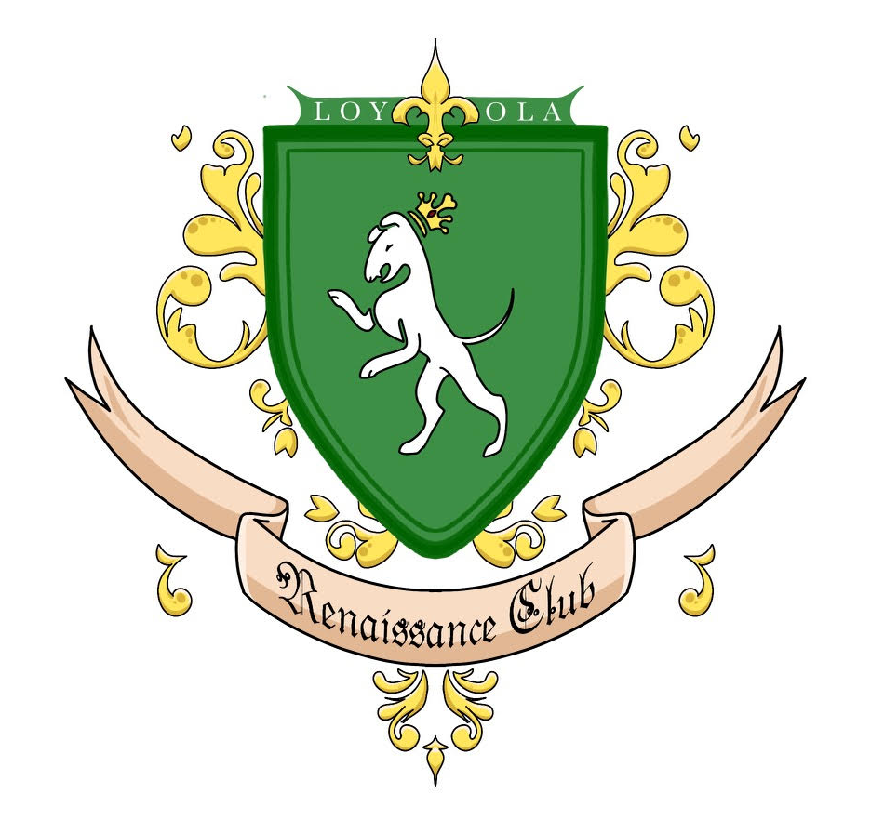

Event Outline

Summary of Event:
- The Loyola Renaissance Society’s goal is to host a “Renaissance Faire”, inspired by similar events across the country and the satirical comedy of the “Monty Python” tradition.
- The event would feature various performances, exhibitions, merchandise, artwork, and other forms of entertainment.
- Student actors, writers, vendors, artists, and medievalists will all contribute to creating a unique experience on Loyola’s campus
- The details for the logistics of the event, explanations of each exhibition, as well as other general info will follow.

I: Location/Time

- The event would take place on March 18th, 2023. The “Rainy Day” date is tentatively March 19th, 2023.
- The event would take place in McGuire Hall. This modification in the proposal is due to concerns regarding weather, scheduling, and logistics.
- The event would take place around 11:30AM-2:00pm, with a timeframe of approximately 2 ½ hours. Time before and after this timeframe will be necessary for setting up/taking down the faire.
- It should be noted that the entirety of McGuire Hall would be needed, with the internal divider pulled back (ex: Relay for Life/First-Year Class Orientation size).
- A tentative Floor Plan is shown below
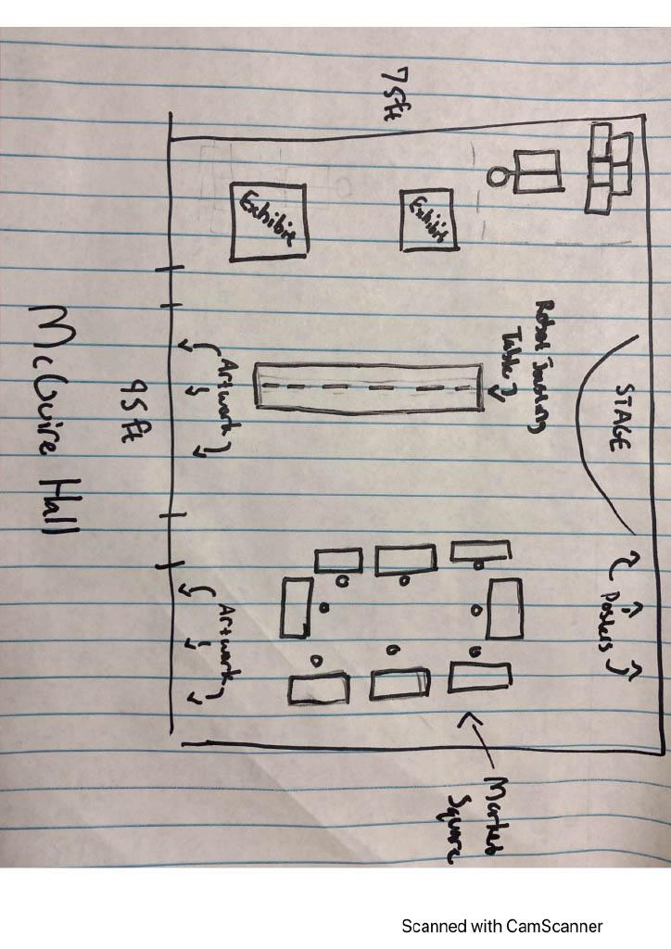

II: Performances

- Over the course of the Faire, 5 short skits in the Renaissance Festival tradition would be displayed on the McGuire stage.
- The skits would be in the medieval Western European fashion, similar in tone and design to Monty Python and the Holy Grail
- Additional period-related musical performances are being considered at this time
- Small, additional performances would also be present around the faire at various times.

III: Exhibitions

- VEX Robotics Jousting
- Partnering with the Loyola VEX Robotics club, a “robot jousting tournament” will be held.
- VEX robots will serve as knights on horseback (ex: Lancebot), placed on a series of tables serving as a track.
- The robots will be driven towards each other in passing lanes, with “lances” aimed at helmets placed on top of each other
- Each robot will represent a “Royal House” of Loyola, named after residential buildings (i.e. House Hammerman, House Bowman, etc.)
- M.C.’s, acting in a similar to Sports Announcers, would commentate
- An example is illustrated below

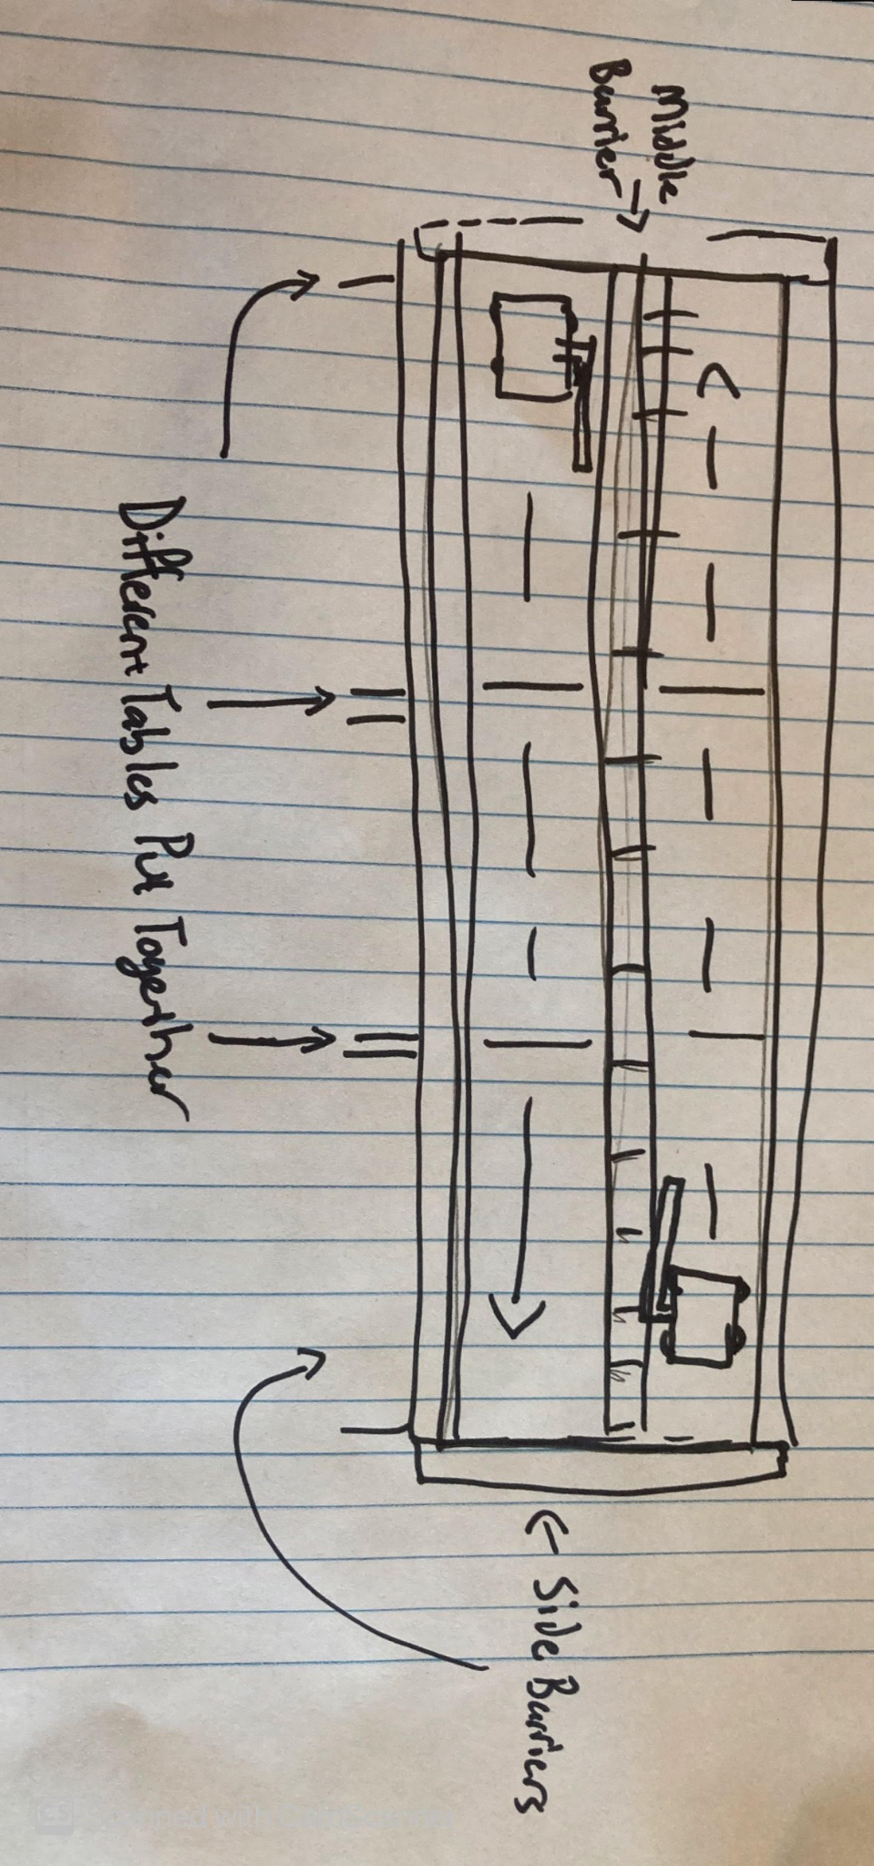

- The Stocks of Charity
- Actors/actresses will be placed in “stocks”, portraying criminals serving their punishment
- People can pay to throw a harmless substance (ex: diced tomatoes, water balloons, paint-covered marshmallows, etc.) at the actor, while they make obnoxious remarks
- All proceeds will go to the Loyola Relay for Life fundraiser
- This exhibition would be placed outside, by the steps leading to McGuire

- Siegeworks/Catapult Corner
- Working with a team of student engineers, two miniature catapults/trebuchets would be constructed.
- In addition, large foam (or other soft material) “Building Blocks” will also be bought and/or produced.
- Under Club supervision and assistance, visitors will be able to launch pillows/soft projectile alternatives over a short distance at the foam “Castle Walls”.
- The angle of such devices would be low, and the devices short ranged, firing a soft projectile. In addition, netting or padding may be set up. Safety equipment such as goggles can also be provided.

- Educational Posters
- Tri-Fold posters created by students would be placed along a wall.
- Such posters would serve as informational displays, covering an element of the Medieval time period (ex: A certain region, city, culture, event, person, technology/innovation, etc.).
- An important aspect of these exhibits is A Globalist perspective; said posters would include topics from across the world.
- In order to be presented, students creating said posters must have their works reviewed and approved by a Loyola faculty member(s) corresponding to the appropriate discipline(s).
- LRS executive Council’s approval will also be necessary

- Artwork/Murals
- Artwork/Decorations created by our design team would be placed around McGuire Hall.
- One example is a spoof on the The Bayeux Tapestry (Which depicts the Battle of Hastings). This work, called The Battle of Charles Street, instead would depict President Sawyer as “King Terrence” and/or the lacrosse Teams of Loyola and John Hopkins.
- A combination of Digital and traditional art will be used to make such decorations and exhibits.

- King Terry and Queen Courtney (Pending Approval)
- If agreed to by President Terrence Sawyer and Professor Courtney Sawyer, the team believes it would be a very popular attraction For the two to make an appearance as Loyola’s Royalty.
- Such an event could include a procession inviting the two to speak, the opportunity to speak with them, and take pictures.

IV: Market Square

- Tables would be set up in a square/rectangular fashion
- Approximately 8-10 student vendors (Number is Flexible) would be invited to sell their wares.
- Such wares may include Pottery, jewelry, artwork, woodwork, homemade products, etc.
- All Student vendors must be approved ahead of time by LRS Executive Board
- A table will be Reserved for the Loyola VEX Robotics Club.
- The Forge
- LRS’ design team will run a Table offering small Blank wooden shields for sale, produced and sanded prior to the event.
- Part of the station will include a painting station, where individuals may paint a sigil or design onto their shield, and leave it under supervision for pickup after said shield dries.

V: Additional Needs & IDeas

- Needs (Either provided or purchased with Club Funding)
- Speakers
- Microphones
- Light Refreshments (provided through Parkhurst)
- Costumes & Props (purchased with Club Funding or provided by individual members)
- Advertisement: LRS would like to place the “Banners” of our “noble houses” in the corresponding residence halls
- Reservation of McGuire Hall for the aforementioned dates before the event is processed on the Bridge

- Further Ideas
- Raffle
- Card table
- Bouncy House/Castle

