**5 Day Wilderness First Responder**

**Intensive**

**Course Information: May 9 - 13**

**Description:**

Do you want to be prepared for a remote accident? Do you want to learn best practices? Are critical thinking and problem solving important to you? If you answered yes to any of the above, then sign up for this scenario based introduction to wilderness medicine.

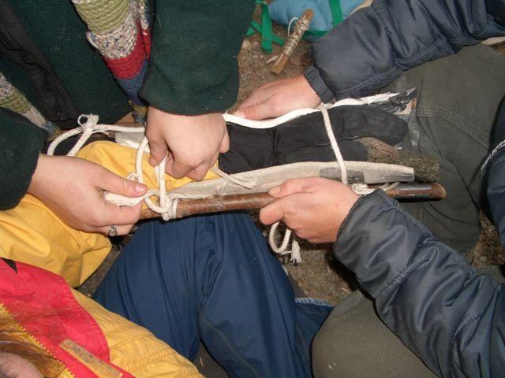

* Develop good assessment and scene leadership skills. Further your risk benefit and decision making skills. Understand real shock. Learn to safely move spine injured patients. Treat ugly wounds and broken bones with greater confidence. Administer epinephrine for severe airway constriction. Recognize situations you can manage alone and when you need to scream for help.
* Each day is devoted to classroom interaction and outdoor practical skills. You should expect scenarios with made up victims and simulated wounds to occur continuously throughout the course.
* This is an intensive five-day course covering a wide spectrum of emergency care topics relative to wilderness medicine and caring for injuries and illnesses over prolonged periods of time.
* The course combines discussions, practical stations and real-life simulations. Topics include assessment and management of traumatic injuries such as fractures, burns and wounds; circulatory, nervous, and respiratory system problems; common injuries such as blisters, sprains and strains; medical problems such as anaphylaxis, toxins, altitude, hypothermia, hyperthermia, and infections; and use of improvised materials in remote situations. The course includes information on personal outdoor preparedness, accident management and prevention and introduces you to simple evacuation techniques and rope work.
* Three-year certification through Wilderness Medical Associates International will be granted following successful completion of the course.

**Who should take the course?**

The course may be taken by anyone who would like to gain practical medical first aid skills.No experience required. This program is designed for the person who frequently travels in the backcountry and is seeking a level of competency beyond basic wilderness first aid. It is an introduction to the broad concepts of rendering care in a remote setting. The course includes CPR training. You can expect the course to be intensive and to cover the most important aspects of wilderness medicine. Normally taught over eight days, this fast track course requires approximately 25 hours of pre-course study.

**Tuition: $700.00**

**To Register:** Contact **Katie Benoit**, Assistant Director of Outdoor Adventures, 410-617-2270 \ [kmbenoit@loyola.edu](mailto:kmbenoit@loyola.edu) or register [online](https://bridge.loyola.edu/oae/rsvp_boot?id=2147911) at https://bridge.loyola.edu/oae/rsvp_boot?id=2147911

**Pre-requisites:**

Students must be at least 16 years old to participate in this course. Those under 18 years of age require the written consent of a parent or guardian.

**When: May 9 - 13**Class days will begin at 8:30 a.m. and end at about 6:00 p.m. These days will be long and intense and you must plan time for evening study. Try to get a good rest and get personal matters out of the way before the course

**Where?** Outdoor Adventure Program room in the Loyola Fitness and Aquatic Center

**Meals:** A 45 - 60 minute lunch break will be provided. Numerous nearby options.

**Lodging:** Numerous nearby lodging options.

**Instructor Profile:** It matters who teaches your course! All of the following courses are led by school owner Jon Tierney. Jon is one of the nation’s most experienced wilderness medicine instructors with over 1800 teaching days and tons of real-life mountain rescue experience. He is a practicing flight paramedic, emergency department nurse and an internationally licensed IFMGA mountain guide. Jon has a highly developed blend of education and experience in outdoor leadership, mountain guiding, backcountry rescue and emergency medicine spanning over three decades. Jon’s resume may be found at <https://acadiamountainguides.com/jon-tierney/>

**Inclusions:**

* 3 year certification from Wilderness Medical Associates International and Anaphylaxis, and BLS/Healthcare Provider-level CPR certification
* Course Texts; SOAP Notes, Wilderness and Rescue Medicine, and The Wilderness Medical Associates Field Guide, Case Study Workbook, Lecture Notes.

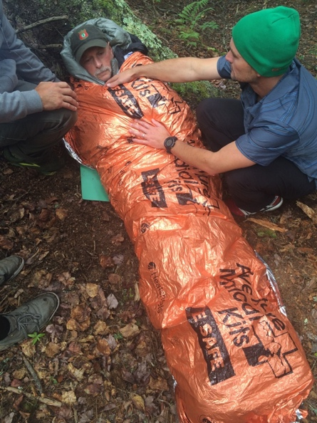

**Exclusions:**

* Meals and lodging
* Participants should bring old clothes and extra clothes for scenarios
* Transportation to / from local scenario sites
* Instructor gratuities

**Supplies:** You will need old throwaway shirts**,** socks and pants for simulations.

**Texts included with course:**

Wilderness and Rescue Medicine: A Guide for Basic & Advanced Practitioners

Wilderness Medicine Workbook

Field Guide of Wilderness & Rescue Medicine

WFR Class Notes

SOAP Note Book

**­­­**

**Gear Discount Perk:**

All participants get a **25% DISCOUNT** off any outdoor equipment or clothing purchased within two weeks before or after the course at [Alpenglow Adventure Sports](https://www.alpenglowgear.com/) and a **LIFETIME 15% DISCOUNT off MSRP.** Purchases may be made in-store or online. Gear purchased in advance of course can often be brought to you on the course.

**Learning Goals:**

* Students will develop improved critical thinking and diagnostic/analytical skills enabling optimum decision-making
* Student will have the skills, knowledge and abilities to provide emergency first aid for a wide array of injuries and conditions in a remote setting
* Students will be able to clearly communicate diagnosis and treatment plan to victims, rescue workers and other expedition members.
* A strong understanding of how to manage the site environment to avoid additional injury to the victim while keeping the site safe for other expedition participants.

**Course Topics:**

WMAI courses present nationally recognized curricula. The style of the course is the result of input from outdoor educators, medical experts, search and rescue personnel, EMS field providers and prior students. Certification through Wilderness Medical Associates International will be granted following successful completion of the course.

* General Concepts in Wilderness and Rescue Medicine
* Patient Assessment System Critical Body Systems: BLS and CPR; Anaphylaxis and Asthma
* Practical Skills: Lifting, Movement and Extrication; Spine Stabilization and Litter Packaging; Improvised Splinting and Litter Construction, Wound Cleaning and Exploration
* Environmental Topics: Exposure Control; Bites and Stings; Altitude Illness; Cold Injuries; Diving Emergencies; Thermoregulation; Lightning; Near Drowning; Avalanche
* Musculoskeletal Systems: Spine Injury Assessment; Musculoskeletal Injuries; Extremity Splinting; Dislocations
* Backcountry Medicine: Routine management and prevention of some common medical problems encountered in the wilderness: sprains and strains, diarrhea, seasickness, minor wounds, urinary infections, dental problems, headaches, etc.
* Other: Medical Legal Issues; Soft Tissue Injury; Toxins; Search and Rescue; Emergency Childbirth; Medical Kits